**DeWitt’s Tree Committee Seeks an Updated Environmental Protection Plan**

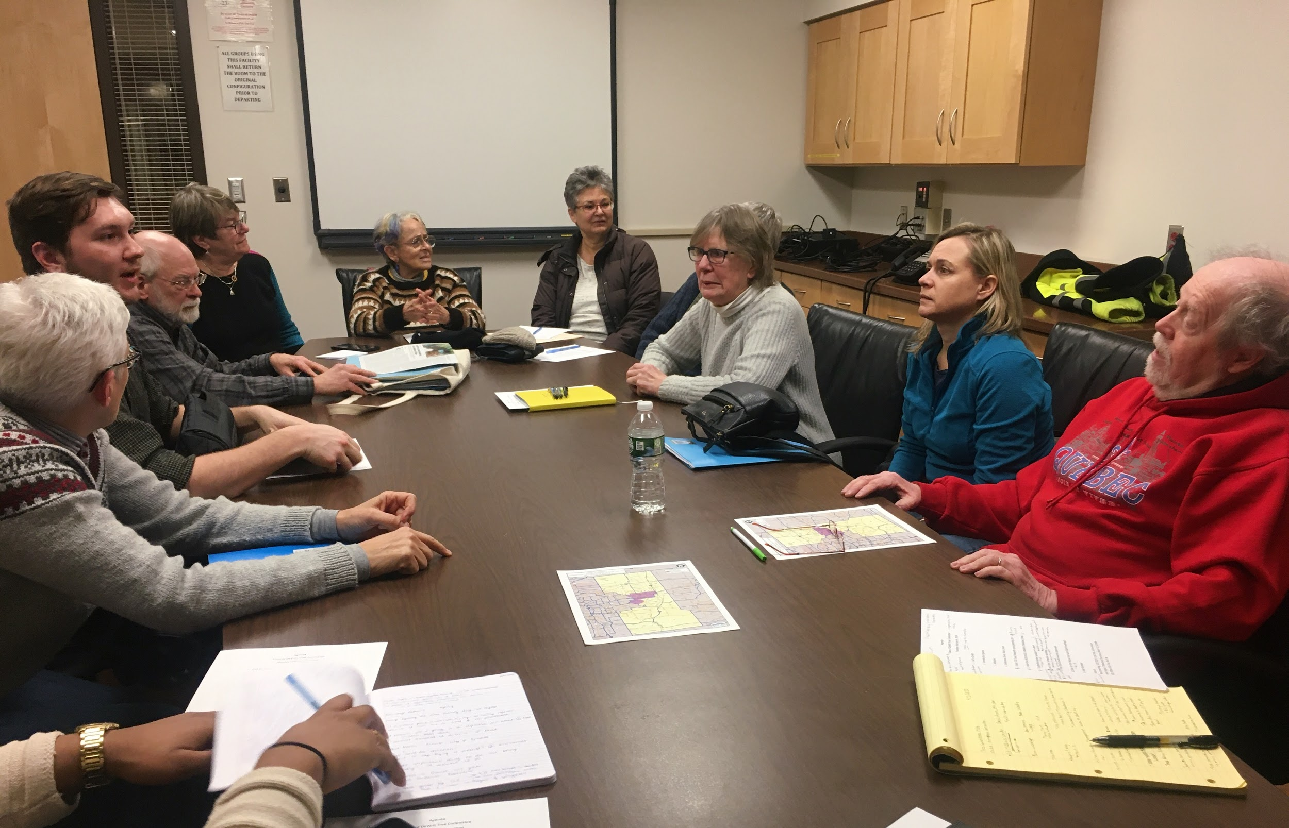

*Members of the DeWitt Tree Committee discussing how to tackle the upcoming months. Photo by Morgan Grenz*

By Morgan Grenz

Every first Tuesday of the month since 2007 an eclectic handful of individuals gather around a table in the small meeting room of the DeWitt Firehouse for a sole purpose, trees. At a glance these meetings may appear as a gathering of old friends, but these passionate townspeople compose the town of DeWitt’s Tree Committee.

The Tree Committee’s second meeting of 2020 was held Feb. 4 at 7 p.m. to discuss their plans for the upcoming months. Ann Stevens, chair of the committee, led the meeting’s agenda where a significant portion of time was allocated to discuss the town’s tree ordinance.

Updating the town's current tree ordinance from more than a decade ago is a top priority for the Tree Committee this year, according to Stevens.

“It’s going to be a big job and there are a lot of unknowns that we have to maneuver through,” Stevens said. “It’s like walking into a forest. You don’t know which path to take.”

*DeWitt’s town planner, Nicholas Quilty-Koval, takes note of departments to call moving forward with an updated town tree ordinance. Photo by Morgan Grenz* 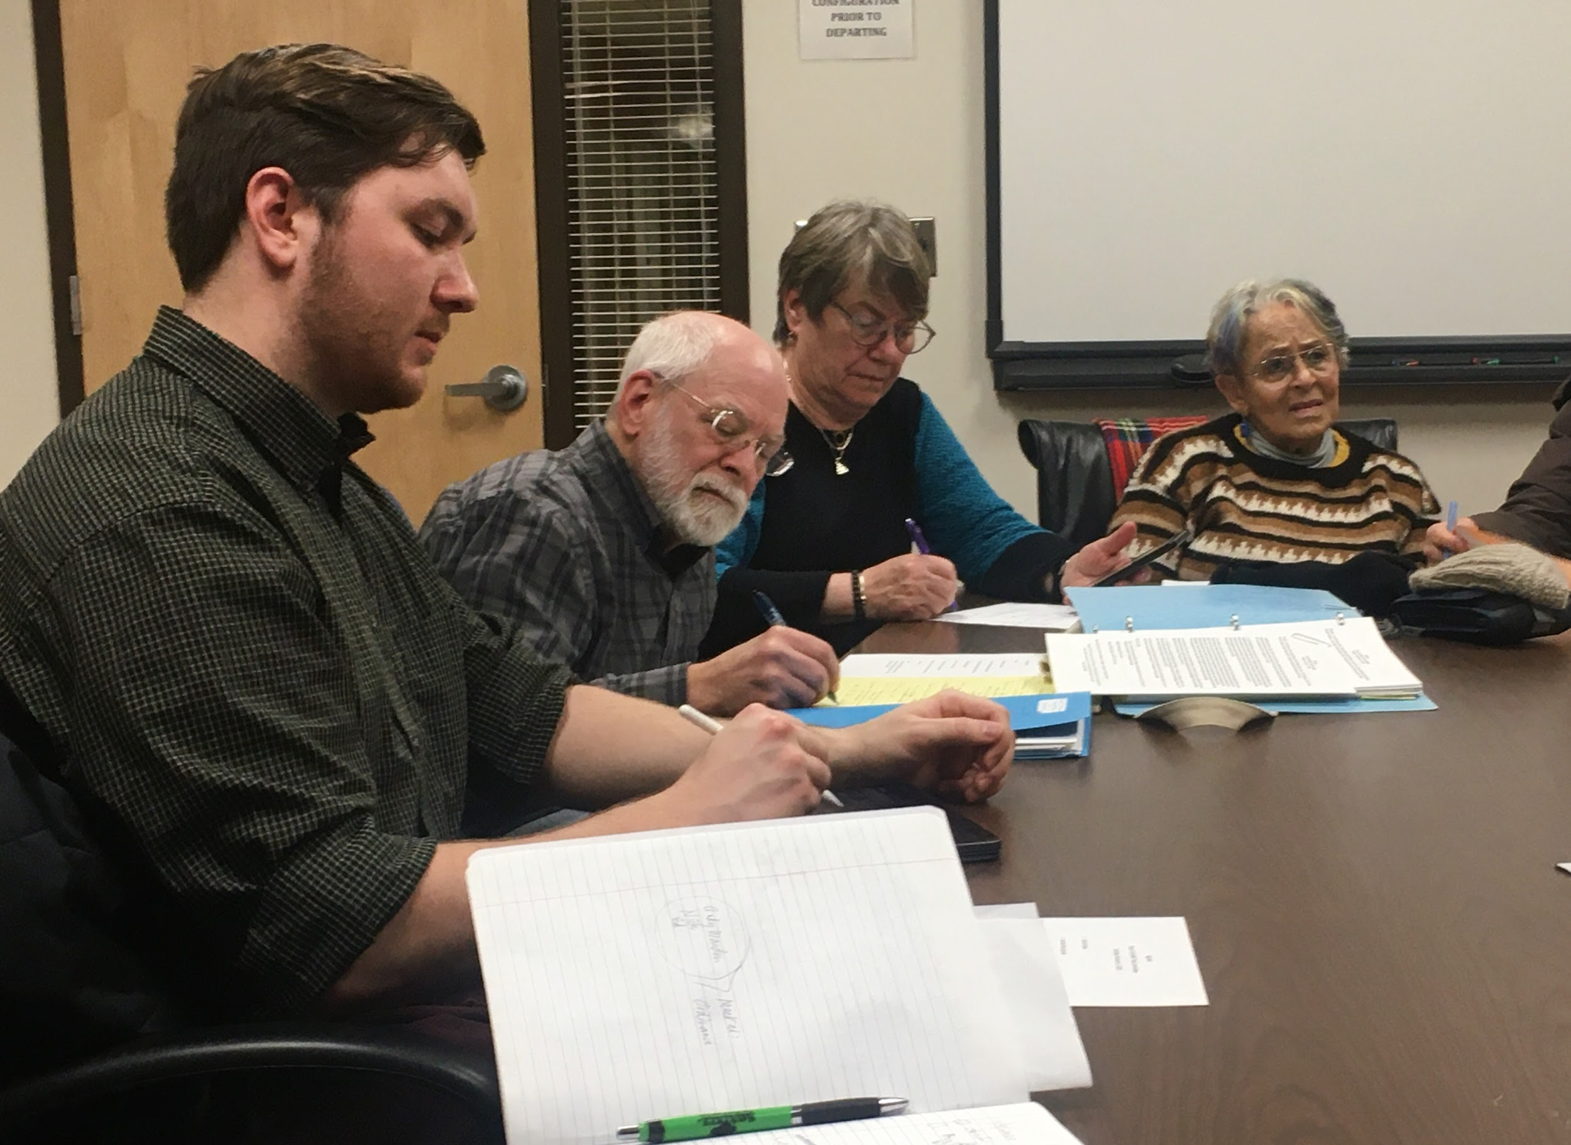

According to DeWitt’s town planner, Nicholas Quilty-Koval, they are looking to strengthen the ordinance in a way that will be beneficial for all members of the community and preserve the natural environment. This entails the Tree Committee bringing all of the affected town departments - such as the highway and parks departments as well as the planning board - together towards a mutual goal.

The committee’s next step after receiving direction from these departments is to put pen to paper by the first of March, Stevens said. They will then seek approval by the town board for their revised plan.

“It’s not pretty and you can’t look at it… But it’s vital,” Stevens said.

Stevens recalled a recent incident where 100 trees were improperly planted on the corner of Kinne Road and Widewaters Parkway as well as maintenance incidents that have occurred along Erie Boulevard involving the pruning and topping of trees by business owners. A newly updated tree ordinance would ideally prevent and protect against this.

The chair of the DeWitt Advisory Conservation Committee, the committee that the Tree Committee was created from, described this kind of preventative environmental work as an investment in themselves.

“If you have a physically attractive community, you’re going to draw visitors and you’re going to draw people who want to live here,” DACC Chair Dennis Payne said.

During the last part of the meeting, the committee moved onto other community initiatives. One of these projects involves the planting of six trees in the spring. They are working with the Cornell Cooperative Extension of Onondaga County to plant these trees in specific areas of DeWitt, according to Quilty-Koval.

These trees will be planted closer to the Le Moyne College area and will help better the urban environment of air quality, limit flooding and improve the general aesthetics of the area, Quilty-Koval said.

Another project that is immediately on the Tree Committee’s radar is the maintenance of the butterfly garden in Ryder Park. This garden was created in a cooperative effort between the Tree Committee and the town recreation department to be used as a learning opportunity to explain the butterfly life cycle to school children.

It has been difficult for the town to not only get the appropriate volunteerism, but also funding for the next steps of the project, Quilty-Koval explained.

Stevens announced at the meeting that the town of DeWitt was awarded Tree City USA from the Arbor Day Foundation for another consecutive year since first awarded in 2009. The town also received the Growth Award for the seventh year in a row.

Stevens describes the significance of these awards as having an ace in their pocket for the year. These acknowledgements make it easier to receive funding for other projects, according to Stevens.